Forum: The forum is a place which clients can leave and share their comments in and the administrator can manage. The forum shows all the comments and encourages the customers to exchange their opinions. It is composed of the add_forum.php, save_forum.php, forum_guest.php, forum_admin.php, and the forum database. The javascript, Ajax, php techniques are used within the structure of forum. add_forum.php is a small window for users to type in their comments and the latter one is a table displaying all the comments. Forum_admin.php is based on forum_guest.php with extra delete function. Save_forum is used to pass the information users typed in to the forum database.

During the development of forum, I have met such difficulties:

Initially problem is combining the add_forum.php with the forum_guest.php with Ajax technique. I find out I can insert the body tag by onload event. Another problem is that without user login function, I have to use one default customer name to add the comment. I used to the flow chart to help me arrange thoughts in order.

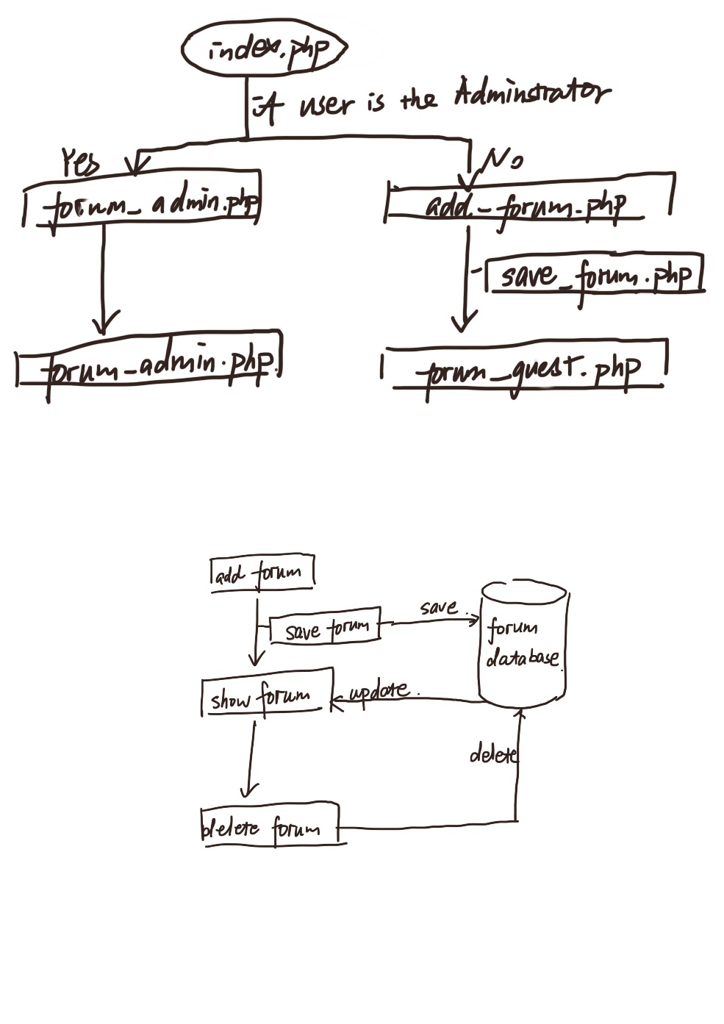

When the user first accesses the forum, he or she can click forum by the navigation bar in the index_log.php (index with user login) or index_nolog.php (index without user login). The user will be regarded as different identity depends on the state of login. If the user has not logged in, which means he is just a guest without ID, then he will be directed to the add_forum.php , if the user is a guest but not the administrator, he will also be directed to add_forum.php. Only the administrator will be forwarded to forum_admin.php.

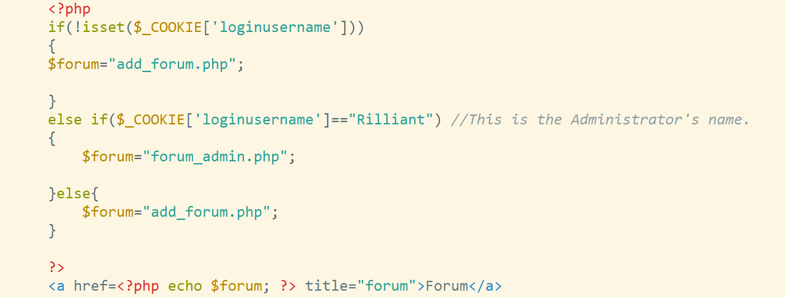

add_forum.php: has three basic element: the comment he want to input; the isAnonymous check box; the submit button. The user can choose whether or not show their name. if they click the anonymous box, then the forum will show “anonymous” instead of their name, if he doesn’t click the anonymous box and without login, the forum will display the “guest” as default name. Otherwise, their name and comments will be shown in the forum_guest.php which is made used of Ajax techniques.

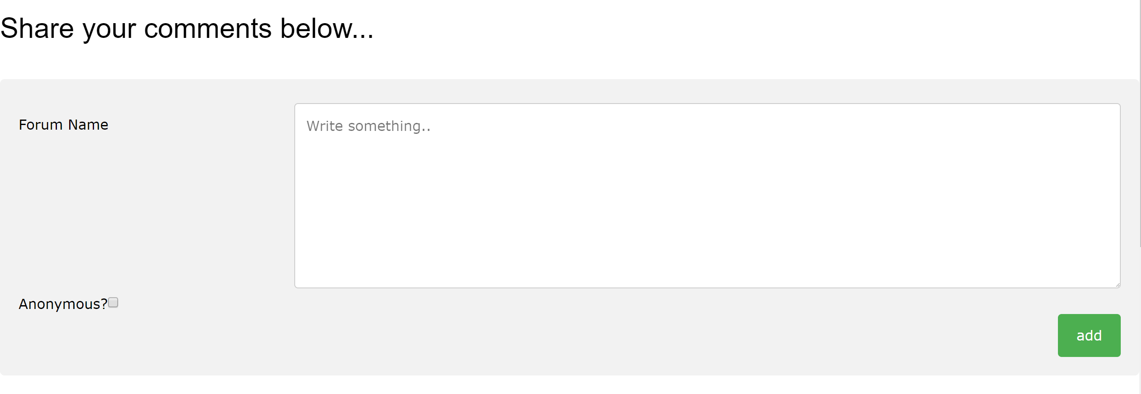

Forum_guest.php: basically contains three columns, the order of comments (the order means the sequence stored in the database and it will be needed use in the delete function of forum_admin.php), the comments and the time together with the user name.

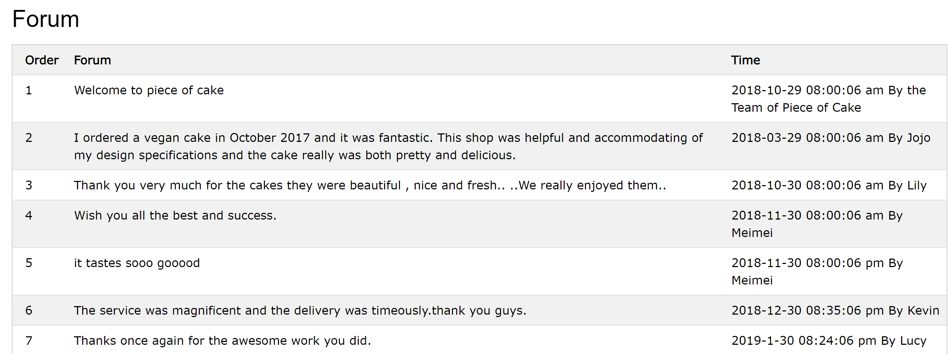

save_forum.php: collected the comments of users in the add_forum.php and passed them to the database.

Forum_admin.php: Only the administrator will be directed to this page. If the administrator clicks the delete button, the function Deleteqry will show the alert box and the delete query is like forum_admin.php?id=.. where id is equal to the order of comments. If the page detects the id is set, it will implement the function delete.

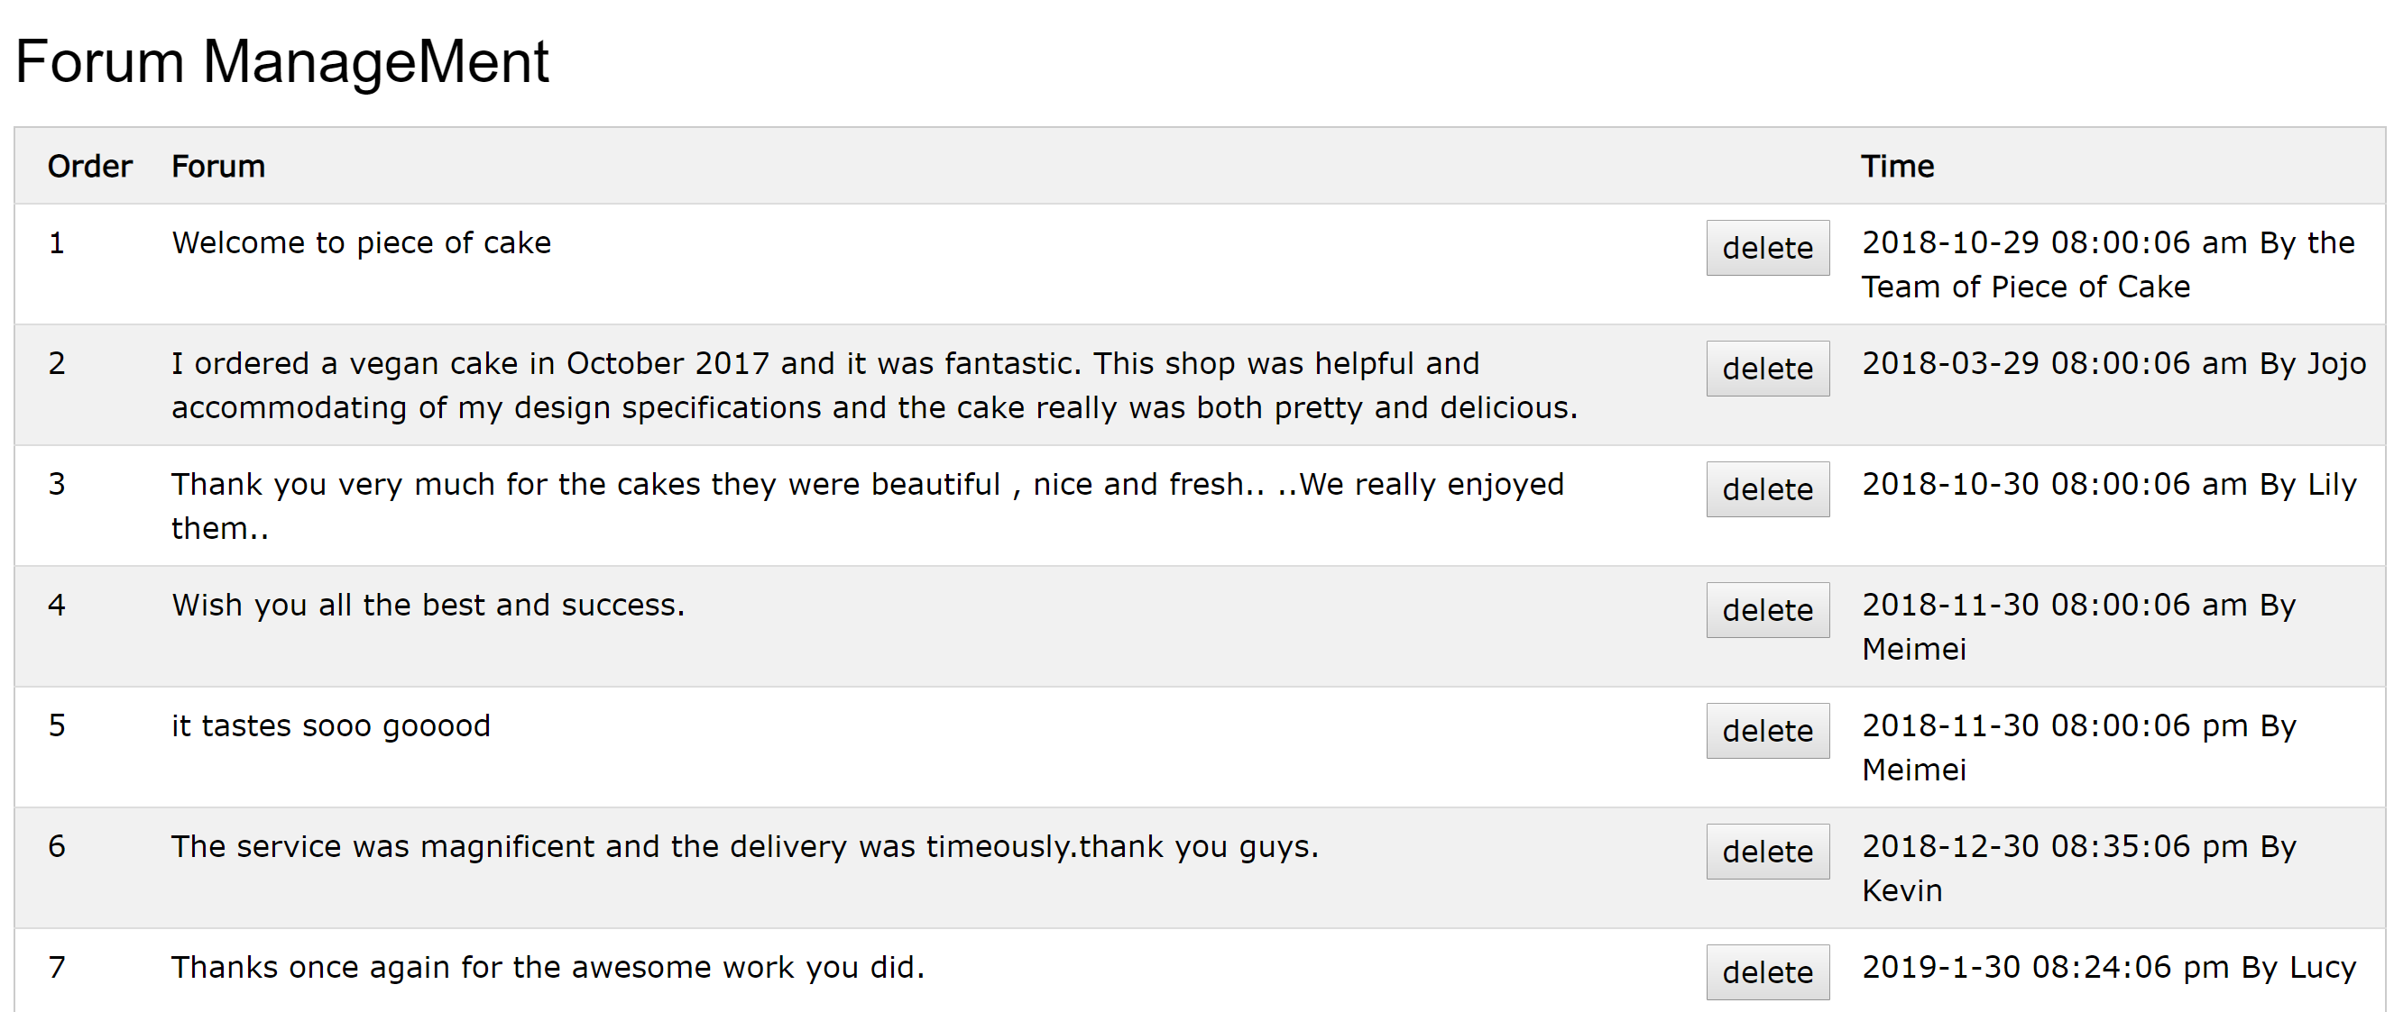

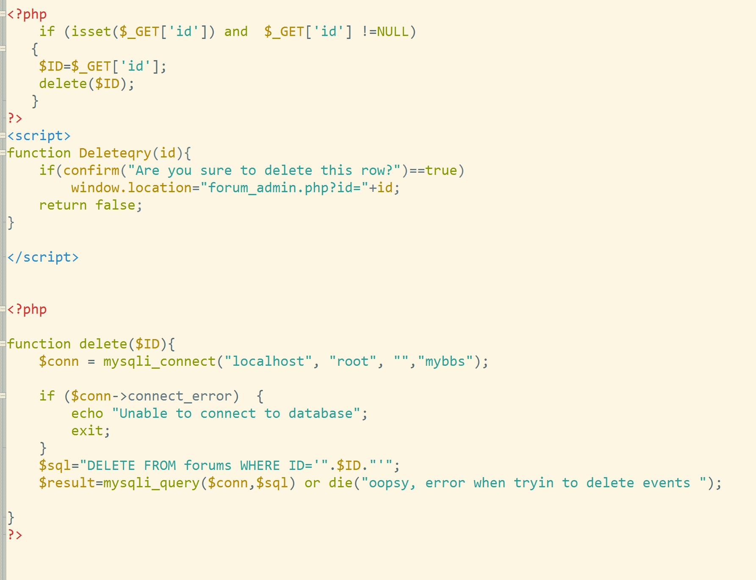

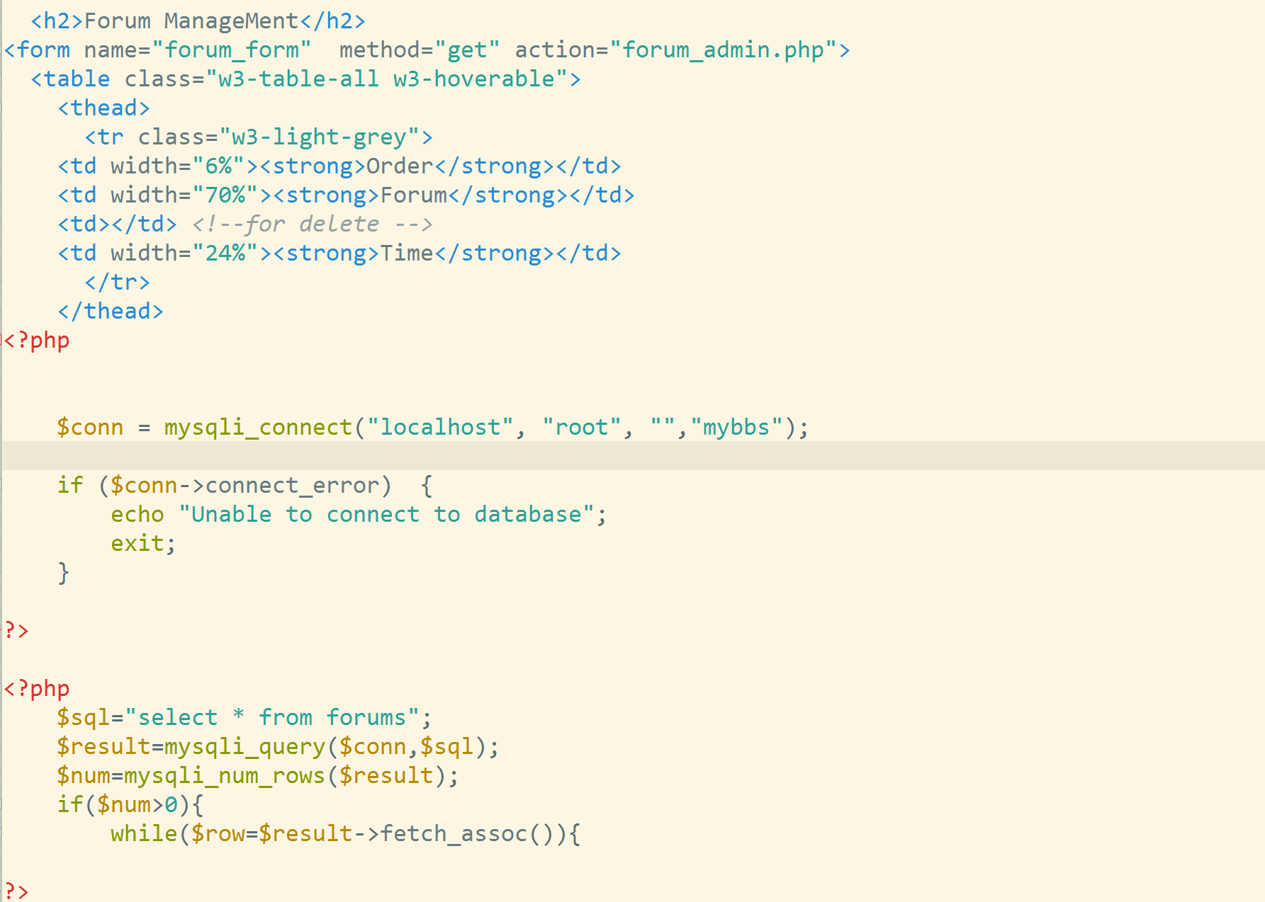

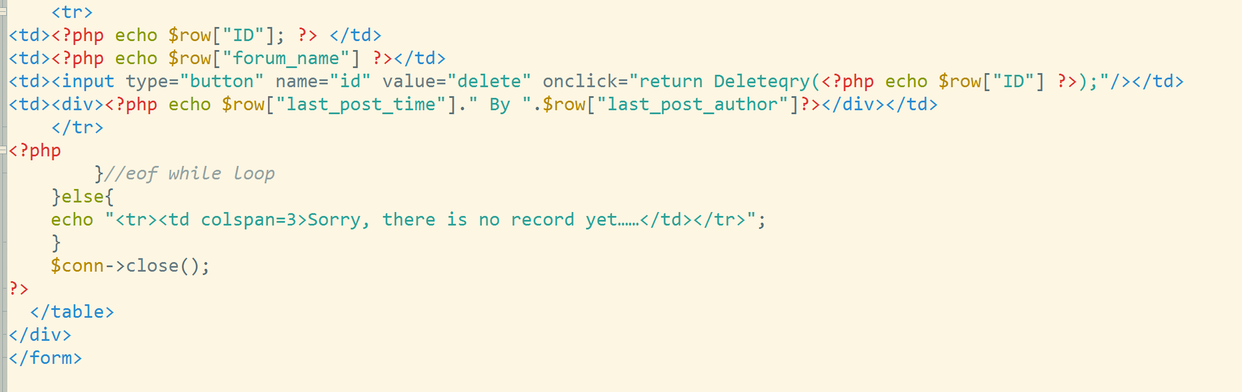

Forum Database:

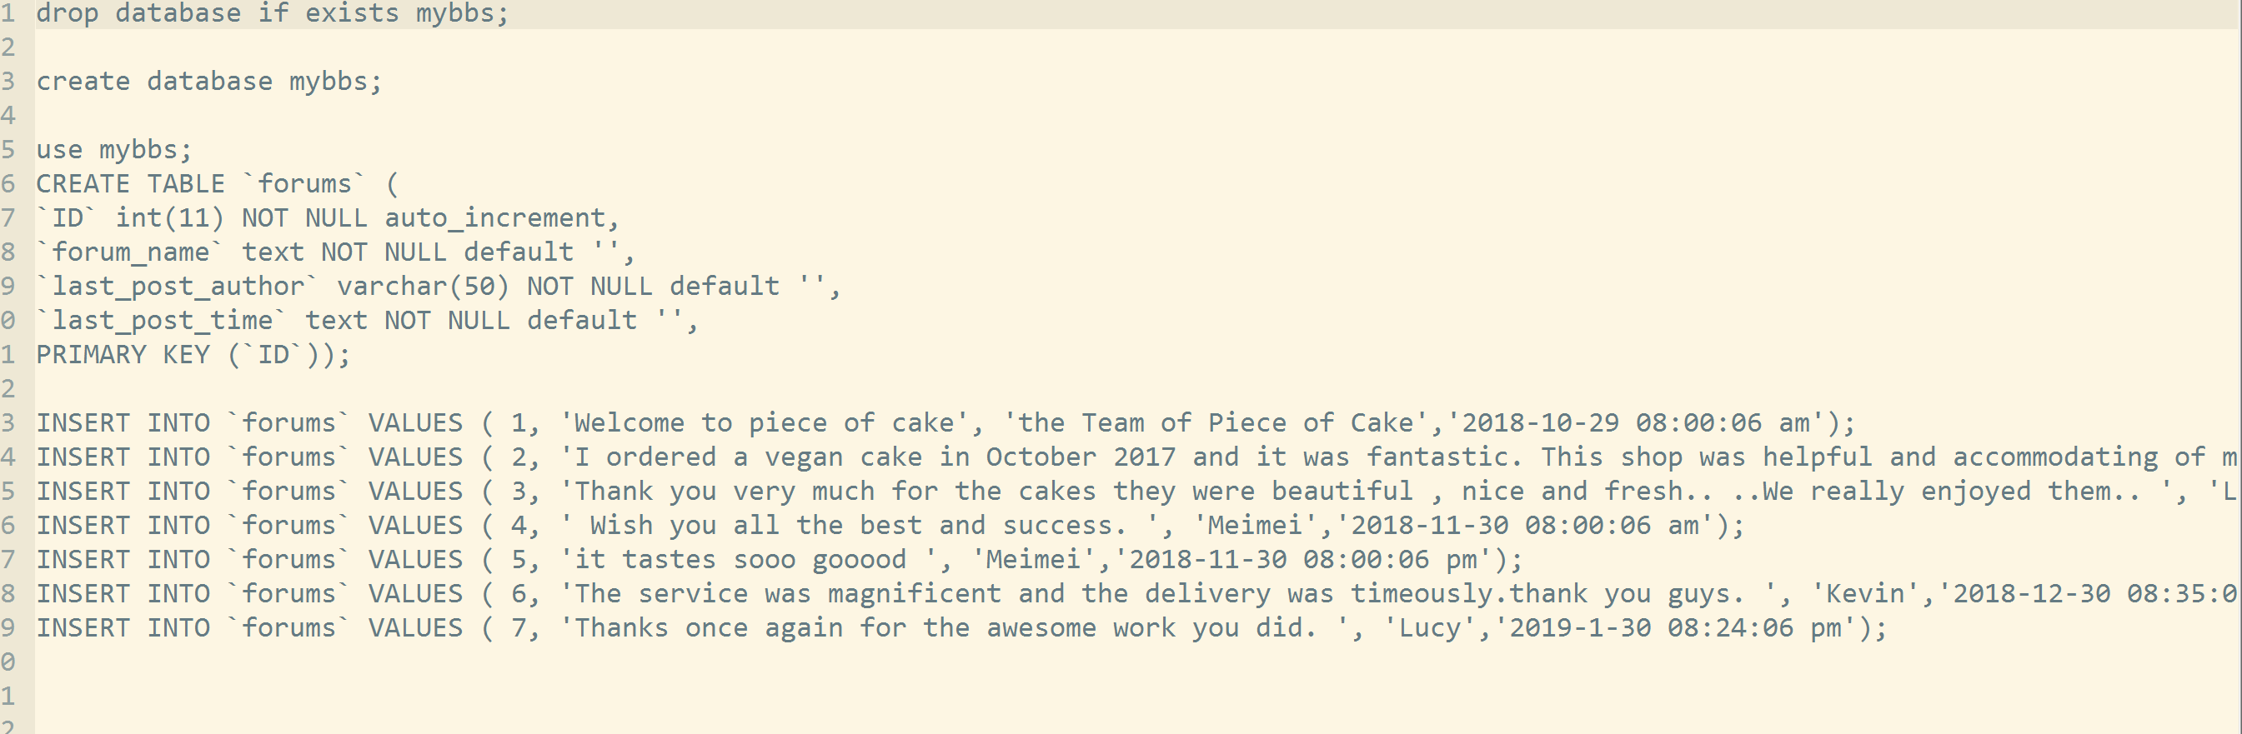

What I find the most troublesome thing is that, since a lot of files are connected. If I have a little modification in one place, I need to correct them all in the other places. Even a single element is important.